Global Cargo Surveillance Tool
ABSTRACT
The foreign freighters tracking tool serves as a global logistics industry tracking visibility and management of cargo transported by international vessels. The tool advanced technology to optimize supply chain processes. The web-based foreign freighters tracking tool is a platform designed to international logistics by in a phase-wise tracking approach including order received, goods loaded, reached destination location, out of delivery and delivered.
Key features of the tool include real-time tracking updates, historical playback functionality, and customizable alerts based on user-defined criteria. The interface provides intuitive visualization of vessel positions, trajectories, and relevant maritime information. Users access the tool via web-based platforms or mobile applications, ensuring accessibility from various devices and locations.
Case studies demonstrate the tool's effectiveness in tracking foreign freighters in challenging environments, such as coastal areas with high traffic density or regions prone to GPS signal disruptions. By relying on diverse data sources and advanced analytics, the tool offers a robust solution for maritime authorities, port operators, and shipping companies to enhance situational awareness and ensure maritime safety and security.

CHAPTER-1
INTRODUCTION
In the dynamic landscape of global logistics, the Web-Based Foreign Freighters Tracking Tool redefines cargo monitoring by adopting a phase-wise tracking paradigm that eschews the conventional reliance on GPS technology. This innovative platform focuses on key milestones in the shipment lifecycle Order Received, Goods Loaded, Reached Destination Location, and Out for Delivery providing stakeholders with real-time visibility into each crucial phase. Through an intuitive web interface, the system aims to optimize supply chain management, offering a privacy conscious alternative to GPS tracking. This introduction marks the inception of a forward-thinking project poised to reshape international freight management through strategic phase-wise tracking.
Future enhancements may include integration with emerging technologies such as machine learning and artificial intelligence to further improve tracking accuracy and predictive capabilities. Additionally, collaboration with international partners and data-sharing initiatives can expand the tool's coverage and effectiveness across different maritime regions.
In conclusion, the proposed non-GPS tracking tool abstract offers a comprehensive solution for monitoring foreign freighters, addressing the limitations of GPS-based tracking in challenging maritime environments. By leveraging alternative technologies and data sources, the tool provides reliable tracking, abstraction, and visualization capabilities, enhancing situational awareness and supporting informed decision-making in maritime operations.
Tracking foreign freighters without relying on GPS presents a significant challenge, particularly in regions with limited coverage or where GPS signals may be intentionally or unintentionally disrupted. In response to this challenge, this paper proposes a non-GPS tracking tool abstract for monitoring foreign freighters, leveraging alternative technologies and data sources. The tool integrates a combination of traditional maritime tracking methods, including Automatic Identification System (AIS), radar, satellite imagery, and Vessel Traffic Services (VTS), to achieve comprehensive coverage and accurate abstraction of vessel movements.

CHAPTER-2
LITERATURE SURVEY
- Title: Research and Implementation of Railway Freight Train Attitude and Center of Gravity Monitoring System
Author: Tianbai Zhang
Abstract: With the development of the express delivery industry, the demand for freight trains on high-speed railways has surged, and monitoring of their operational safety has become increasingly important. However, many re-searches on the operation status of high-speed freight trains at home and abroad cannot meet the complex and changeable characteristics of high-speed railways. Therefore, using the quaternion self-fusion algorithm and the first-order complementary filtering algorithm, the existing inertial sensor MPU-6050, combined with wireless serial communication technology and Lab-VIEW software on the host, designed a strong real-time, stable Good train condition monitoring system. Through the system's static test and dynamic inspection, the accuracy and stability of the system data were evaluated, and the need for real-time monitoring of train operating conditions was met.

- Title: Is AI and Digitization New Avatar for Air Freighters and Forwarders
Author: Ashok Chopra
Abstract: General observation points out that Start-Ups normally dominate Technology Disruption as they are constantly looking for those left out segments of markets, which have been overlooked by established players. This phenomenon can be currently seen in the crowded airfreight industry where start-up AI companies are promising air freighters with productivity efficiency and enhancement because of rising costs. AI start Ups are also offering services like major upcoming mega-events so that freighter and airlines can tap potential customers and relevant stakeholders for revenue and bottom-line enhancement. The airlines are also attracted to such AI start Ups, because of the IATA forecast for the current fiscal year, "a decline in global profits for airlines". As per IATA, overall profits are set to decline by 7% to $28 billion in the year 2020. Today AI is even promising to make inroads in a spectrum of operations areas, like targeted advertising, aircraft maintenance offering relative demand comparison services to airlines. The net result of these is benefits for freighter and carriers who change their offering, after looking at the high demand for freight or focus on filling seats at lower prices when they know there will be slower periods for passenger seats and lean demand for the freight sector. Airlines and freighters whose portfolios have significant dependence on freight are turning towards research-based AI tools rather than gazing at crystal ball or sky gazing through spreadsheet matching events versus their offerings. AI startups have also started making inroads on one hand in providing insights to airlines on high-value cargo, and other hand promising passengers with lucrative benefits of alternative flights to accommodate cargo's weight. Further service experienced by B2C (which is raised by Online Retailing Co. like Amazon, Flipkart) is now has a domino effect on B2B organizations especially for freight forwarders who are looking for data to raise their standard bars. This exploratory paper draws data from literature and secondary sources to drive the point that how AI is making inroads on the freight and cargo industry of the future. It also paints a realistic picture of the future of these industries.

- Title: Extracting Global Shipping Networks from Massive Historical Automatic Identification System Sensor Data: A Bottom-Up Approach
Author: zhihuan Wang
Abstract: The increasing availability of big Automatic Identification Systems (AIS) sensor data offers great opportunities to track ship activities and mine spatial-temporal patterns of ship traffic worldwide. This research proposes a data integration approach to construct Global Shipping Networks (GSN) from massive historical ship AIS trajectories in a completely bottom-up way. First, a DBSCAN (Density-Based Spatial Clustering of Applications with Noise) algorithm is applied to temporally identify relevant stop locations, such as marine terminals and their associated events. Second, the semantic meanings of these locations are obtained by mapping them to real ports as identified by the World Port Index (WPI). Stop events are leveraged to develop travel sequences of any ship between stop locations at multiple scales. Last, a GSN is constructed by considering stop locations as nodes and journeys between nodes as links. This approach generates different levels of shipping networks from the terminal, port, and country levels. It is illustrated by a case study that extracts country, port, and terminal level Global Container Shipping Networks (GCSN) from AIS trajectories of more than 4000 container ships in 2015. The main features of these GCSNs and the limitations of this work are finally discussed.

CHAPTER-3
SYSTEM ANALYSIS
  - EXISTING SYSYEM:
The existing system for tracking foreign freighters involves a combination of technologies and methods to monitor vessel movements and ensure maritime safety. It includes Automatic Identification System (AIS), which broadcasts vessel information such as identity, position, course, and speed. Radar systems detect and track vessels in real-time, complementing AIS data especially in adverse weather conditions. Satellite imagery provides a broader coverage, aiding in monitoring vessel traffic in remote or poorly covered regions. Vessel Traffic Services (VTS) manage vessel traffic in busy maritime areas, utilizing radar, AIS data, and visual observation. Ports deploy surveillance systems comprising CCTV cameras and AIS receivers to monitor vessel activities within port limits. Collaborative data sharing agreements facilitate the exchange of vessel tracking data among maritime entities, enhancing situational awareness. International regulations mandate the use of tracking and communication equipment on vessels for safety and security purposes. Emergency response systems integrate data from AIS, radar, satellite imagery, and VTS to coordinate response efforts during emergencies, such as search and rescue operations or maritime incidents.
DISADVANTAGES:
- Limited Granularity: The absence of continuous tracking may limit the granularity of location data, potentially impacting the precision of information available for stakeholders.
- Dependency on Manual Inputs: Relying on manual updates introduces the risk of human error, leading to inaccurate or delayed information about the status of shipments.
- Reduced Visibility During Transit: Lack of continuous tracking could result in periods where the exact location and condition of cargo are not readily available, reducing overall visibility.
- Inability to Predict Delays: The system may face challenges in accurately predicting delays during transit, impacting the ability to proactively address issues or optimize shipping routes in real-time.
  - PROPOSED SYSTEM
The proposed system for tracking foreign freighters without relying on GPS aims to enhance monitoring capabilities and ensure maritime safety through innovative technologies and methodologies. It integrates a combination of existing tracking systems such as Automatic Identification System (AIS), radar, satellite imagery, and Vessel Traffic Services (VTS), while also introducing new elements to improve accuracy and coverage. Key components of the proposed system Overall, the proposed system aims to enhance the existing tracking capabilities for foreign freighters by integrating advanced technologies, predictive analytics, and user-friendly features to improve accuracy, coverage, and operational efficiency in maritime surveillance and safety.
- Focused Milestones: The phased tracking system simplifies the monitoring process by focusing on key milestones such as Order Received, Goods Loaded, Reached Destination Location, and Out for Delivery. This clarity enhances overall understanding and management of the shipment lifecycle.
- Reduced Technology Dependency: Eliminating the need for GPS tracking reduces technological dependencies, making the system more resilient to potential outages or disruptions in satellite communication. This could enhance the overall reliability of the tracking tool.
- Privacy-Conscious Approach: The absence of continuous location tracking addresses privacy concerns associated with GPS technology. This approach aligns with evolving privacy regulations and provides reassurance to stakeholders wary of extensive surveillance.
- Simplified Implementation: Implementing a phase-wise tracking system can be more straightforward compared to complex GPS technologies. This simplicity may result in quicker deployment, allowing businesses to adapt rapidly to changing logistics needs.
- Cost Efficiency: Phase-wise tracking could be more cost-effective than continuous GPS monitoring, especially for businesses with budget constraints. The reduced need for high-tech infrastructure and satellite communication could lead to significant cost savings.

CHAPTER-4
SYSTEM REQUIRMENTS

4.1 HARDWARE REQUIREMENTS:
- PROCESSOR : i5.
- Hard Disk : 913GB.
- Ram : 8 GB.

4.2 SOFTWARE REQUIREMENTS:

- Operating system : Windows.
- Coding Language : JAVA/J2EE
- Data Base : MYSQL
- IDE : Netbeans8.1

CHAPTER-5
SYSTEM STUDY

5.1 FEASIBILITY STUDY
The feasibility of the project is analyzed in this phase and business proposal is put forth with a very general plan for the project and some cost estimates. During system analysis the feasibility study of the proposed system is to be carried out. This is to ensure that the proposed system is not a burden to the company. For feasibility analysis, some understanding of the major requirements for the system is essential.
5.2 FEASIBILITY ANALYSIS
Three key considerations involved in the feasibility analysis are
- ECONOMICAL FEASIBILITY
- TECHNICAL FEASIBILITY
- SOCIAL FEASIBILITY
ECONOMICAL FEASIBILITY
This study is carried out to check the economic impact that the system will have on the organization. The amount of fund that the company can pour into the research and development of the system is limited. The expenditures must be justified. Thus, the developed system as well within the budget and this was achieved because most of the technologies used are freely available. Only the customized products had to be purchased.
TECHNICAL FEASIBILITY
This study is carried out to check the technical feasibility, that is, the technical requirements of the system. Any system developed must not have a high demand on the available technical resources. This will lead to high demands on the available technical resources. This will lead to high demands being placed on the client. The developed system must have a modest requirement, as only minimal or null changes are required for implementing this system.
SOCIAL FEASIBILITY
The aspect of study is to check the level of acceptance of the system by the user. This includes the process of training the user to use the system efficiently. The user must not feel threatened by the system, instead must accept it as a necessity. The level of acceptance by the users solely depends on the methods that are employed to educate the user about the system and to make him familiar with it. His level of confidence must be raised so that he is also able to make some constructive criticism, which is welcomed, as he is the final user of the system.

CHAPTER-6
SYSTEM DESIGN

SYSTEM ARCHITECTURE:
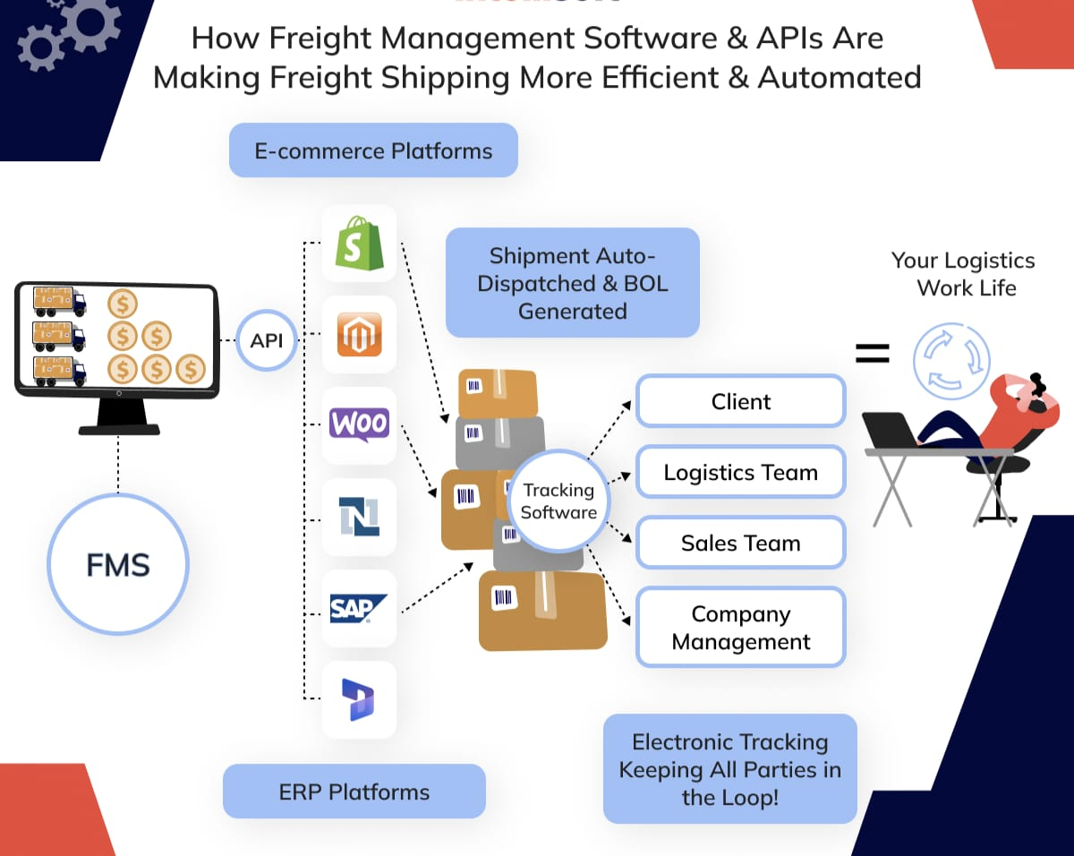
6.2 UML DIAGRAMS
UML stands for Unified Modeling Language. UML is a standardized general-purpose modeling language in the field of object-oriented software engineering. The standard is managed, and was created by, the Object Management Group.
The goal is for UML to become a common language for creating models of object-oriented computer software. In its current form UML is comprised of two major components: a Meta-model and a notation. In the future, some form of method or process may also be added to; or associated with, UML.
The Unified Modeling Language is a standard language for specifying, Visualization, Constructing and documenting the artifacts of software system, as well as for business modeling and other non-software systems.
The UML represents a collection of best engineering practices that have proven successful in the modeling of large and complex systems.
The UML is a very important part of developing objects-oriented software and the software development process. The UML uses mostly graphical notations to express the design of software projects.
GOALS:
The Primary goals in the design of the UML are as follows:
- Provide users a ready-to-use, expressive visual modeling Language so that they can develop and exchange meaningful models.
- Provide extendibility and specialization mechanisms to extend the core concepts.
- Be independent of particular programming languages and development process.
- Provide a formal basis for understanding the modeling language.
- Encourage the growth of OO tools market.
- Support higher level development concepts such as collaborations, frameworks, patterns and components.
- Integrate best practices.

6.2.1 USE CASE DIAGRAM:
A use case diagram in the Unified Modeling Language (UML) is a type of behavioral diagram defined by and created from a Use-case analysis. Its purpose is to present a graphical overview of the functionality provided by a system in terms of actors, their goals (represented as use cases), and any dependencies between those use cases. The main purpose of a use case diagram is to show what system functions are performed for which actor. Roles of the actors in the system can be depicted.
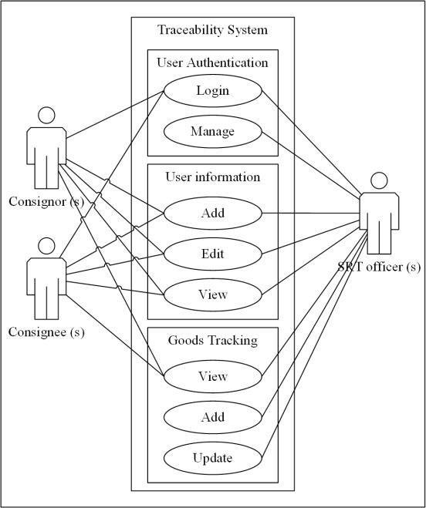

6.2.2 CLASS DIAGRAM:
In software engineering, a class diagram in the Unified Modeling Language (UML) is a type of static structure diagram that describes the structure of a system by showing the system's classes, their attributes, operations (or methods), and the relationships among the classes. It explains which class contains information. Class diagrams are a fundamental tool in object-oriented modeling and are widely used in software development.
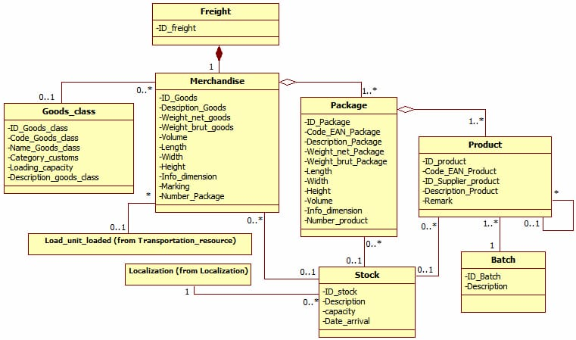

6.2.3 SEQUENCE DIAGRAM:
A sequence diagram in Unified Modeling Language (UML) is a kind of interaction diagram that shows how processes operate with one another and in what order. It is a construct of a Message Sequence Chart. Sequence diagrams are sometimes called event diagrams, event scenarios, and timing diagrams.
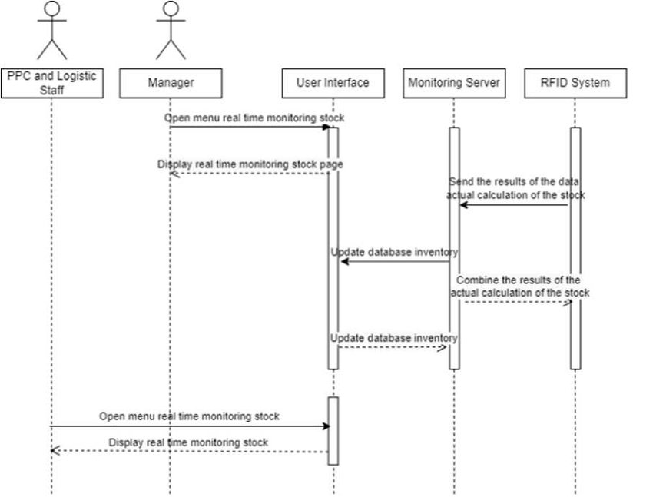

6.2.4 COLLABARATION DIAGRAM :
A Collabaration diagram, also known as a Communication diagram, is a type of Unified Modeling Language (UML) diagram used to visually represent the interactions and communication between objects or components in a system or software application. It focuses on showing how various objects or components collaborate to achieve specific functionality or a particular use case. Collaboration diagrams are particularly useful for understanding the dynamic aspects of a system and how objects interact over time.
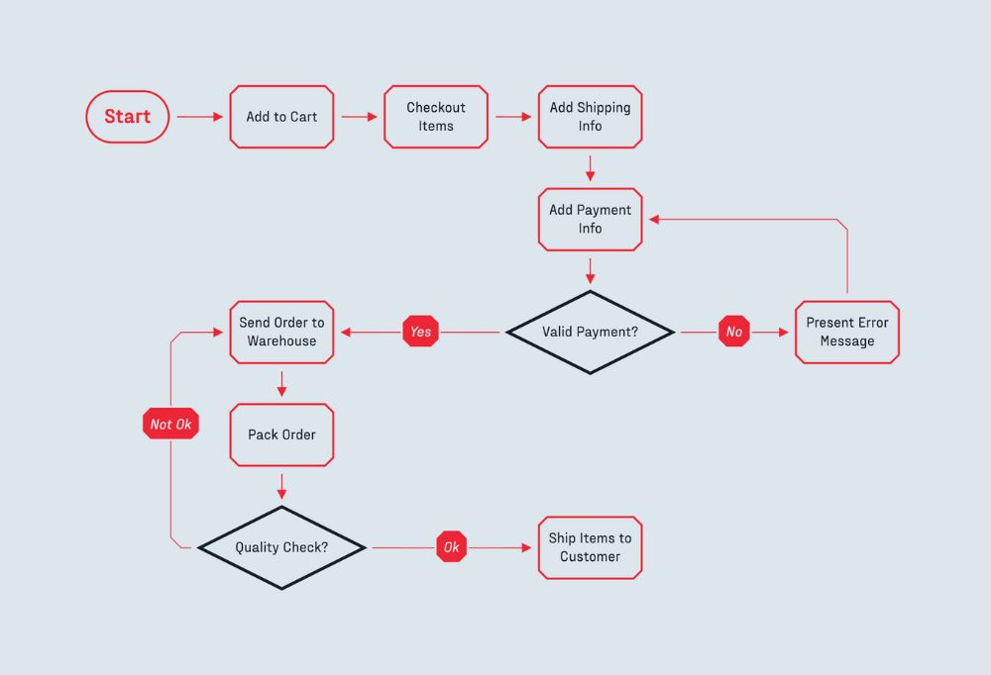

6.2.5 ACTIVITY DIAGRAM :
An Activity diagram is a type of Unified Modeling Language (UML) diagram that is used to model the dynamic aspects of a system, particularly the flow of activities and actions within a business process, use case, or other system behaviors. Activity diagrams provide a graphicalrepresentation of how different activities and actions are organized and interact to achieve a specific goal.Activity diagrams help stakeholders, including analysts, designers, and developers, to understand the sequential and parallel flows of activities and make them a valuable tool for system design and documentation.
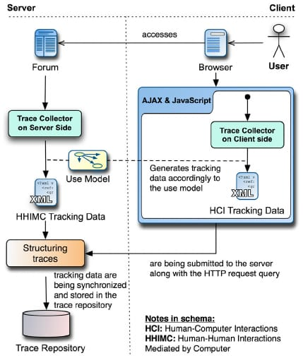

CHAPTER-7
INPUT AND OUTPUT DESIGN
7.1 INPUT DESIGN
The input design is the link between the information system and the user. It comprises the developing specification and procedures for data preparation and those steps are necessary to put transaction data in to a usable form for processing can be achieved by inspecting the computer to read data from a written or printed document or it can occur by having people keying the data directly into the system. The design of input focuses on controlling the amount of input required, controlling the errors, avoiding delay, avoiding extra steps and keeping the process simple. The input is designed in such a way so that it provides security and ease of use with retaining the privacy. Input Design considered the following things:
- What data should be given as input?
- How the data should be arranged or coded?
- The dialog to guide the operating personnel in providing input.
- Methods for preparing input validations and steps to follow when error occur.

7.1.1 OBJECTIVES
1.Input Design is the process of converting a user-oriented description of the input into a computer-based system. This design is important to avoid errors in the data input process and show the correct direction to the management for getting correct information from the computerized system.
2. It is achieved by creating user-friendly screens for the data entry to handle large volume of data. The goal of designing input is to make data entry easier and to be free from errors. The data entry screen is designed in such a way that all the data manipulates can be performed. It also provides record viewing facilities.
3.When the data is entered it will check for its validity. Data can be entered with the help of screens. Appropriate messages are provided as when needed so that the user will not be in maize of instant. Thus the objective of input design is to create an input layout that is easy to follow.
7.2 OUTPUT DESIGN
A quality output is one, which meets the requirements of the end user and presents the information clearly. In any system results of processing are communicated to the users and to other system through outputs. In output design it is determined how the information is to be displaced for immediate need and also the hard copy output. It is the most important and direct source information to the user. Efficient and intelligent output design improves the system’s relationship to help user decision-making.
1. Designing computer output should proceed in an organized, well thought out manner; the right output must be developed while ensuring that each output element is designed so that people will find the system can use easily and effectively. When analysis design computer output, they should Identify the specific output that is needed to meet the requirements.
2.Select methods for presenting information.
3.Create document, report, or other formats that contain information produced by the system.
The output form of an information system should accomplish one or more of the following objectives.
- Convey information about past activities, current status or projections of the
- Future.
- Signal important events, opportunities, problems, or warnings.
- Trigger an action.
- Confirm an action.

CHAPTER-8
IMPLEMENTATION
A module is a self-contained unit of code or functionality that can be reused or combined with other modules to create a larger system. Modules can help you organize your code, improve readability, and facilitate testing and maintenance.
8.1 MODULES
- USER MODULE
- ADMIN MODULE
- WEB SERVICE MODULE
- DATABASE MODULE
8.1.1 MODULE DESCRIPTION
User Interface Module:
A user interface module that handles the front-end web development, such as displaying the web page layout, design, and content. This module can use HTML, CSS, and JavaScript to create a responsive and user-friendly website for Foreign Freighters Tracking Tool.
Web Service Module:
A web service module that handles the back-end web development, such as connecting to the server, database, and other web services. This module can use Java, Spring Boot, and JSON to create a web service that generates and consumes data from the relational database and other sources.
Database Module:
A database module that handles the data storage and retrieval, such as storing and querying the information about the charging stations, their locations, availability, and other details. This module can use MySQL or another relational database management system to create and manage the database tables and schemas.

CHAPTER-9
SOFTWARE ENVIRONMENT
9.1 PYTHON
Python is a high-level, interpreted, interactive and object-oriented scripting language. Python is designed to be highly readable. It uses English keywords frequently where as other languages use punctuation, and it has fewer syntactical constructions than other languages.
• Python is Interpreted: Python is processed at runtime by the interpreter. You do not need to compile your program before executing it. This is similar to PERL and PHP.
• Python is Interactive: You can actually sit at a Python prompt and interact with the interpreter directly to write your programs.
• Python is Object-Oriented: Python supports Object-Oriented style or technique of programming that encapsulates code within objects.
• Python is a Beginner’s Language: Python is a great language for the beginner-level programmers and supports the development of a wide range of applications from simple text processing to WWW browsers to games.
History of Python
Python was developed by Guido van Rossum in the late eighties and early nineties at the National Research Institute for Mathematics and Computer Science in the Netherlands.
Python is derived from many other languages, including ABC, Modula-3, C, C++, Algol-68, SmallTalk, and Unix shell and other scripting languages.
Python is copyrighted. Like Perl, Python source code is now available under the GNU General Public License (GPL).
Python is now maintained by a core development team at the institute, although Guido van Rossum still holds a vital role in directing its progress.

Python Features
Python’s features include:
• Easy-to-learn: Python has few keywords, simple structure, and a clearly defined syntax. This allows the student to pick up the language quickly.
• Easy-to-read: Python code is more clearly defined and visible to the eyes.
• Easy-to-maintain: Python’s source code is fairly easy-to-maintain.
• A broad standard library: Python’s bulk of the library is very portable and cross-platform compatible on UNIX, Windows, and Macintosh.

• Interactive Mode: Python has support for an interactive mode which allows interactive testing and debugging of snippets of code.
• Portable: Python can run on a wide variety of hardware platforms and has the same interface on all platforms.
• Extendable: You can add low-level modules to the Python interpreter. These modules enable programmers to add to or customize their tools to be more efficient.
• Databases: Python provides interfaces to all major commercial databases.
• GUI Programming: Python supports GUI applications that can be created and ported to many system calls, libraries and windows systems, such as Windows MFC, Macintosh, and the X Window system of Unix.
• Scalable: Python provides a better structure and support for large programs than shell scripting.
Python has a big list of good features:
• It supports functional and structured programming methods as well as OOP.
• It can be used as a scripting language or can be compiled to byte-code for building large applications.
• It provides very high-level dynamic data types and supports dynamic type checking.
• IT supports automatic garbage collection.
• It can be easily integrated with C, C++, COM, ActiveX, CORBA, and Java.

ARITHMETIC OPERATORS

Operator Description Example
+ Addition Adds values on either side of the operator. a + b = 30
- Subtraction Subtracts right hand operand from left hand operand. a – b = -10
* Multiplication Multiplies values on either side of the operator a * b = 200
/ Division Divides left hand operand by right hand operand b / a = 2
% Modulus Divides left hand operand by right hand operand and returns remainder b % a = 0
** Exponent Performs exponential (power) calculation on operators a**b =10 to the power 20
// Floor Division - The division of operands where the result is the quotient in which the digits after the decimal point are removed. But if one of the operands is negative, the result is floored, i.e., rounded away from zero (towards negative infinity): 9//2 = 4 and 9.0//2.0 = 4.0, -11//3 = -4, -11.0//3 = -4.0

ASSIGNMENT OPERATOR

Operator Description Example
= Assigns values from right side operands to left side operand c = a + b assigns value of a + b into c
+= Add AND It adds right operand to the left operand and assign the result to left operand c += a is equivalent to c = c + a
-= Subtract AND It subtracts right operand from the left operand and assign the result to left operand c -= a is equivalent to c = c - a
*= Multiply AND It multiplies right operand with the left operand and assign the result to left operand c *= a is equivalent to c = c * a
/= Divide AND It divides left operand with the right operand and assign the result to left operand c /= a is equivalent to c = c / ac /= a is equivalent to c = c / a

%= Modulus AND It takes modulus using two operands and assign the result to left operand c %= a is equivalent to c = c % a
**= Exponent AND Performs exponential (power) calculation on operators and assign value to the left operand c **= a is equivalent to c = c ** a
//= Floor Division It performs floor division on operators and assign value to the left operand c //= a is equivalent to c = c // a

IDENTITY OPERATOR

Operator Description Example
is Evaluates to true if the variables on either side of the operator point to the same object and false otherwise. x is y, here is results in 1 if id(x) equals id(y).
is not Evaluates to false if the variables on either side of the operator point to the same object and true otherwise. x is not y, here is not results in 1 if id(x) is not equal to id(y

COMPARISON OPERATOR

Operator Description Example
& Binary AND Operator copies a bit to the result if it exists in both operands (a & b) (means 0000 1100)
| Binary OR It copies a bit if it exists in either operand. (a | b) = 61 (means 0011 1101)
^ Binary XOR It copies the bit if it is set in one operand but not both. (a ^ b) = 49 (means 0011 0001)
~ Binary Ones Complement It is unary and has the effect of ‘flipping’ bits. (~a ) = -61 (means 1100 0011 in 2’s complement form due to a signed binary number.
<< Binary Left Shift The left operands value is moved left by the number of bits specified by the right operand. a << 2 = 240 (means 1111 0000)
>> Binary Right Shift The left operands value is moved right by the number of bits specified by the right operand. a >> 2 = 15 (means 0000 1111)

LOGICAL OPERATOR

Operator Description Example
and Logical AND If both the operands are true then condition becomes true. (a and b) is true.
or Logical OR If any of the two operands are non-zero then condition becomes true. (a or b) is true.
not Logical NOT Used to reverse the logical state of its operand. Not(a and b) is false.

Membership Operators

Operator Description Example
in Evaluates to true if it finds a variable in the specified sequence and false otherwise. x in y, here in results in a 1 if x is a member of sequence y.
not in Evaluates to true if it does not finds a variable in the specified sequence and false otherwise. x not in y, here not in results in a 1 if x is not a member of sequence y.

Python Operators Precedence
Operator Description
** Exponentiation (raise to the power)
~ + - Complement, unary plus and minus (method names for the last two are +@ and -@)
* / % // Multiply, divide, modulo and floor division
+ - Addition and subtraction
>> << Right and left bitwise shift
& Bitwise ‘AND’
^ | Bitwise exclusive `OR’ and regular `OR’
<= < > >= Comparison operators
<> == != Equality operators
= %= /= //= -= += *= **= Assignment operators
is is not Identity operators
in not in Membership operators
not or and Logical operators
LIST
The list is a most versatile data type available in Python which can be written as a list of comma-separated values (items) between square brackets. Important thing about a list is that items in a list need not be of the same type.
Creating a list is as simple as putting different comma-separated values between square brackets. For example −
list1 = [’physics’, ‘chemistry’, 1997, 2000];
list2 = [1, 2, 3, 4, 5 ];
list3 = [”a”, “b”, “c”, “d”]
Basic List Operations
Lists respond to the + and * operators much like strings; they mean concatenation and repetition here too, except that the result is a new list, not a string.
Python Expression Results Description
len([1, 2, 3]) 3 Length
[1, 2, 3] + [4, 5, 6] [1, 2, 3, 4, 5, 6] Concatenation
[’Hi!’] * 4 [’Hi!’, ‘Hi!’, ‘Hi!’, ‘Hi!’] Repetition
3 in [1, 2, 3] True Membership
for x in [1, 2, 3]: print x, 1 2 3 Iteration

Built-in List Functions & Methods:
Python includes the following list functions −
SN Function with Description
1 cmp(list1, list2)
Compares elements of both lists.
2 len(list)
Gives the total length of the list.
3 max(list)
Returns item from the list with max value.
4 min(list)
Returns item from the list with min value.
5 list(seq)
Converts a tuple into list.

Python includes following list methods
SN Methods with Description
1 list.append(obj)
Appends object obj to list
2 list.count(obj)
Returns count of how many times obj occurs in list
3 list. extend(seq)
Appends the contents of seq to list
4 list.index(obj)
Returns the lowest index in list that obj appears
5 list.insert(index, obj)
Inserts object obj into list at offset index
6 list.pop(obj=list[-1])
Removes and returns last object or obj from list
7 list.remove(obj)
Removes object obj from list
8 list.reverse()
Reverses objects of list in place
9 list.sort([func])
Sorts objects of list, use compare function if given

TUPLES
A tuple is a sequence of immutable Python objects. Tuples are sequences, just like lists. The differences between tuples and lists are, the tuples cannot be changed unlike lists and tuples use parentheses, whereas lists use square brackets.
Creating a tuple is as simple as putting different comma-separated values. Optionally we can put these comma-separated values between parentheses also. For example −
tup1 = (’physics’, ‘chemistry’, 1997, 2000);
tup2 = (1, 2, 3, 4, 5 );
tup3 = “a”, “b”, “c”, “d”;
The empty tuple is written as two parentheses containing nothing −
tup1 = ();
To write a tuple containing a single value you have to include a comma, even though there is only one value −
tup1 = (50,);
Like string indices, tuple indices start at 0, and they can be sliced, concatenated, and so on.
• Accessing Values in Tuples:
To access values in tuple, use the square brackets for slicing along with the index or indices to obtain value available at that index. For example –
tup1 = (’physics’, ‘chemistry’, 1997, 2000);
tup2 = (1, 2, 3, 4, 5, 6, 7 );
print “tup1[0]: “, tup1[0]
print “tup2[1:5]: “, tup2[1:5]
When the code is executed, it produces the following result −
tup1[0]: physics
tup2[1:5]: [2, 3, 4, 5]

Updating Tuples:
Tuples are immutable which means you cannot update or change the values of tuple elements. We are able to take portions of existing tuples to create new tuples as the following example demonstrates −

tup1 = (12, 34.56);
tup2 = (’abc’, ‘xyz’);
tup3 = tup1 + tup2;
print tup3
When the above code is executed, it produces the following result −
(12, 34.56, ‘abc’, ‘xyz’)

Delete Tuple Elements
Removing individual tuple elements is not possible. There is, of course, nothing wrong with putting together another tuple with the undesired elements discarded.
To explicitly remove an entire tuple, just use the del statement. For example:
tup = (’physics’, ‘chemistry’, 1997, 2000);
print tup
del tup;
print “After deleting tup : “
print tup

Basic Tuples Operations:
Python Expression Results Description
len((1, 2, 3)) 3 Length
(1, 2, 3) + (4, 5, 6) (1, 2, 3, 4, 5, 6) Concatenation
(’Hi!’,) * 4 (’Hi!’, ‘Hi!’, ‘Hi!’, ‘Hi!’) Repetition
3 in (1, 2, 3) True Membership
for x in (1, 2, 3): print x, 1 2 3 Iteration
Built-in Tuple Functions
SN Function with Description
1 cmp(tuple1, tuple2):Compares elements of both tuples.
2 len(tuple):Gives the total length of the tuple.
3 max(tuple):Returns item from the tuple with max value.
4 min(tuple):Returns item from the tuple with min value.
5 tuple(seq):Converts a list into tuple.

DICTIONARY
Each key is separated from its value by a colon (:), the items are separated by commas, and the whole thing is enclosed in curly braces. An empty dictionary without any items is written with just two curly braces, like this: {}.
Keys are unique within a dictionary while values may not be. The values of a dictionary can be of any type, but the keys must be of an immutable data type such as strings, numbers, or tuples.
Accessing Values in Dictionary:
To access dictionary elements, you can use the familiar square brackets along with the key to obtain its value. Following is a simple example −
dict = {’Name’: ‘Zara’, ‘Age’: 7, ‘Class’: ‘First’}

print “dict[’Name’]: “, dict[’Name’]
print “dict[’Age’]: “, dict[’Age’]
Result –
dict[’Name’]: Zara
dict[’Age’]: 7Updating Dictionary
We can update a dictionary by adding a new entry or a key-value pair, modifying an existing entry, or deleting an existing entry as shown below in the simple example −
dict = {’Name’: ‘Zara’, ‘Age’: 7, ‘Class’: ‘First’}

dict[’Age’] = 8; # update existing entry
dict[’School’] = “DPS School”; # Add new entry
print “dict[’Age’]: “, dict[’Age’]
print “dict[’School’]: “, dict[’School’]
Result −
dict[’Age’]: 8
dict[’School’]: DPS School

Delete Dictionary Elements
We can either remove individual dictionary elements or clear the entire contents of a dictionary. You can also delete entire dictionary in a single operation.
To explicitly remove an entire dictionary, just use the del statement. Following is a simple example –
dict = {’Name’: ‘Zara’, ‘Age’: 7, ‘Class’: ‘First’}

del dict[’Name’]; # remove entry with key ‘Name’
dict.clear(); # remove all entries in dict
del dict ; # delete entire dictionary

print “dict[’Age’]: “, dict[’Age’]
print “dict[’School’]: “, dict[’School’]

Built-in Dictionary Functions & Methods –
Python includes the following dictionary functions −
SN Function with Description
1 cmp(dict1, dict2)
Compares elements of both dict.
2 len(dict)
Gives the total length of the dictionary. This would be equal to the number of items in the dictionary.
3 str(dict)
Produces a printable string representation of a dictionary
4 type(variable)
Returns the type of the passed variable. If passed variable is dictionary, then it would return a dictionary type.

Python includes following dictionary methods −
SN Methods with Description
1 dict.clear():Removes all elements of dictionary dict
2 dict. Copy():Returns a shallow copy of dictionary dict
3 dict.fromkeys():Create a new dictionary with keys from seq and values set to value.
4 dict.get(key, default=None):For key key, returns value or default if key not in dictionary
5 dict.has_key(key):Returns true if key in dictionary dict, false otherwise
6 dict.items():Returns a list of dict’s (key, value) tuple pairs
7 dict.keys():Returns list of dictionary dict’s keys
8 dict.setdefault(key, default=None):Similar to get(), but will set dict[key]=default if key is not already in dict
9 dict.update(dict2):Adds dictionary dict2’s key-values pairs to dict
10 dict.values():Returns list of dictionary dict’s values

A function is a block of organized, reusable code that is used to perform a single, related action. Functions provide better modularity for your application and a high degree of code reusing. Python gives you many built-in functions like print(), etc. but you can also create your own functions. These functions are called user-defined functions.

Defining a Function
Simple rules to define a function in Python.
• Function blocks begin with the keyword def followed by the function name and parentheses ( ( ) ).
• Any input parameters or arguments should be placed within these parentheses. You can also define parameters inside these parentheses.
• The first statement of a function can be an optional statement - the documentation string of the function or docstring.
• The code block within every function starts with a colon (:) and is indented.
• The statement return [expression] exits a function, optionally passing back an expression to the caller. A return statement with no arguments is the same as return None.
def functionname( parameters ):
“function_docstring”
function_suite
return [expression]
Calling a Function
Defining a function only gives it a name, specifies the parameters that are to be included in the function and structures the blocks of code.Once the basic structure of a function is finalized, you can execute it by calling it from another function or directly from the Python prompt. Following is the example to call printme() function −
# Function definition is here
def printme( str ):
“This prints a passed string into this function”
print str
return;
# Now you can call printme function
printme(”I’m first call to user defined function!”)
printme(”Again second call to the same function”)
When the above code is executed, it produces the following result −
I’m first call to user defined function!
Again second call to the same function
Function Arguments
You can call a function by using the following types of formal arguments:
• Required arguments
• Keyword arguments
• Default arguments
• Variable-length arguments

Scope of Variables
All variables in a program may not be accessible at all locations in that program. This depends on where you have declared a variable.
The scope of a variable determines the portion of the program where you can access a particular identifier. There are two basic scopes of variables in Python −
Global variables Local variables
Global vs. Local variables
Variables that are defined inside a function body have a local scope, and those defined outside have a global scope.
This means that local variables can be accessed only inside the function in which they are declared, whereas global variables can be accessed throughout the program body by all functions. When you call a function, the variables declared inside it are brought into scope. Following is a simple example −

total = 0; # This is global variable.
# Function definition is here
def sum( arg1, arg2 ):
# Add both the parameters and return them.”
total = arg1 + arg2; # Here total is local variable.
print “Inside the function local total : “, total
return total;
sum( 10, 20 );
print “Outside the function global total : “, total
Result −
Inside the function local total : 30
Outside the function global total : 0

A module allows you to logically organize your Python code. Grouping related code into a module makes the code easier to understand and use. A module is a Python object with arbitrarily named attributes that you can bind and reference.Simply, a module is a file consisting of Python code. A module can define functions, classes and variables. A module can also include runnable code.
Example:
The Python code for a module named aname normally resides in a file named aname.py. Here’

A module allows you to logically organize your Python code. Grouping related code into a module makes the code easier to understand and use. A module is a Python object with arbitrarily named attributes that you can bind and reference.Simply, a module is a file consisting of Python code. A module can define functions, classes and variables. A module can also include runnable code.
Example:
The Python code for a module named aname normally resides in a file named aname.py. Here’s an example of a simple module, support.py
def print_func( par ):
print “Hello : “, par
return

The import Statement
The import has the following syntax:
import module1[, module2[,... moduleN]
When the interpreter encounters an import statement, it imports the module if the module is present in the search path. A search path is a list of directories that the interpreter searches before importing a module. For example, to import the module support.py, you need to put the following command at the top of the script −
A module is loaded only once, regardless of the number of times it is imported. This prevents the module execution from happening over and over again if multiple imports occur.
Packages in Python
A package is a hierarchical file directory structure that defines a single Python application environment that consists of modules and sub packages and sub-sub packages.
Consider a file Pots.py available in Phone directory. This file has following line of source code −
def Pots():
print “I’m Pots Phone”
Similar way, we have another two files having different functions with the same name as above −
• Phone/Isdn.py file having function Isdn()
• Phone/G3.py file having function G3()
Now, create one more file __init__.py in Phone directory −
• Phone/__init__.py

To make all of your functions available when you’ve imported Phone,to put explicit import statements in __init__.py as follows −
from Pots import Pots
from Isdn import Isdn
from G3 import G3
After you add these lines to __init__.py, you have all of these classes available when you import the Phone package.
# Now import your Phone Package.
import Phone
Phone.Pots()
Phone.Isdn()
Phone.G3()
RESULT:
I’m Pots Phone
I’m 3G Phone
I’m ISDN Phone
In the above example, we have taken example of a single functions in each file, but you can keep multiple functions in your files. You can also define different Python classes in those files and then you can create your packages out of those classes.
This chapter covers all the basic I/O functions available in Python.
Printing to the Screen
The simplest way to produce output is using the print statement where you can pass zero or more expressions separated by commas. This function converts the expressions you pass into a string and

writes the result to standard output as follows −
print “Python is really a great language,”, “isn’t it?”
Result:
Python is really a great language, isn’t it?
Reading Keyboard Input
Python provides two built-in functions to read a line of text from standard input, which by default comes from the keyboard. These functions are −
• raw_input
• input
The raw_input Function
The raw_input([prompt]) function reads one line from standard input and returns it as a string (removing the trailing newline).
str = raw_input(”Enter your input: “);
print “Received input is : “, str
This prompts you to enter any string and it would display same string on the screen. When I typed “Hello Python!”, its output is like this −
Enter your input: Hello Python
Received input is : Hello Python
The input Function
The input([prompt]) function is equivalent to raw_input, except that it assumes the input is a valid Python expression and returns the evaluated result to you.
str = input(”Enter your input: “);
print “Received input is : “, str
This would produce the following result against the entered input −
Enter your input: [x*5 for x in range(2,10,2)]
Recieved input is : [10, 20, 30, 40]
Opening and Closing Files
Until now, you have been reading and writing to the standard input and output. Now, we will see how to use actual data files.
Python provides basic functions and methods necessary to manipulate files by default. You can do most of the file manipulation using a file object.
The open Function
Before you can read or write a file, you have to open it using Python’s built-in open() function. This function creates a file object, which would be utilized to call other support methods associated with it.
Syntax
file object = open(file_name [, access_mode][, buffering])
Here are parameter details:
• file_name: The file_name argument is a string value that contains the name of the file that you want to access.
• access_mode: The access_mode determines the mode in which the file has to be opened, i.e., read, write, append, etc. A complete list of possible values is given below in the table. This is optional parameter and the default file access mode is read (r).
• buffering: If the buffering value is set to 0, no buffering takes place. If the buffering value is 1, line buffering is performed while accessing a file. If you specify the buffering value as an integer greater than 1, then buffering action is performed with the indicated buffer size. If negative, the buffer size is the system default(default behavior).
Here is a list of the different modes of opening a file −
Modes Description
r Opens a file for reading only. The file pointer is placed at the beginning of the file. This is the default mode.
rb Opens a file for reading only in binary format. The file pointer is placed at the beginning of the file. This is the default mode.
r+ Opens a file for both reading and writing. The file pointer placed at the beginning of the file.
rb+ Opens a file for both reading and writing in binary format. The file pointer placed at the beginning of the file.
w Opens a file for writing only. Overwrites the file if the file exists. If the file does not exist, creates a new file for writing.
wb Opens a file for writing only in binary format. Overwrites the file if the file exists. If the file does not exist, creates a new file for writing.
w+ Opens a file for both writing and reading. Overwrites the existing file if the file exists. If the file does not exist, creates a new file for reading and writing.
wb+ Opens a file for both writing and reading in binary format. Overwrites the existing file if the file exists. If the file does not exist, creates a new file for reading and writing.
a Opens a file for appending. The file pointer is at the end of the file if the file exists. That is, the file is in the append mode. If the file does not exist, it creates a new file for writing.
ab Opens a file for appending in binary format. The file pointer is at the end of the file if the file exists. That is, the file is in the append mode. If the file does not exist, it creates a new file for writing.
a+ Opens a file for both appending and reading. The file pointer is at the end of the file if the file exists. The file opens in the append mode. If the file does not exist, it creates a new file for reading and writing.
ab+ Opens a file for both appending and reading in binary format. The file pointer is at the end of the file if the file exists. The file opens in the append mode. If the file does not exist, it creates a new file for reading and writing.
The file Object Attributes
Once a file is opened and you have one file object, you can get various information related to that file.
Here is a list of all attributes related to file object:
Attribute Description
file.closed Returns true if file is closed, false otherwise.
file.mode Returns access mode with which file was opened.
file.name Returns name of the file.
file.softspace Returns false if space explicitly required with print, true otherwise.
Example
# Open a file
fo = open(”foo.txt”, “wb”)
print “Name of the file: “, fo.name
print “Closed or not : “, fo.closed
print “Opening mode : “, fo.mode
print “Softspace flag : “, fo.softspace
This produces the following result −
Name of the file: foo.txt
Closed or not : False
Opening mode : wb
Softspace flag : 0
The close() Method
The close() method of a file object flushes any unwritten information and closes the file object, after which no more writing can be done.Python automatically closes a file when the reference object of a file is reassigned to another file. It is a good practice to use the close() method to close a file
Syntax
fileObject.close();
Example
# Open a file
fo = open(”foo.txt”, “wb”)
print “Name of the file: “, fo.name
# Close opend file
fo.close()
Result −
Name of the file: foo.txt
Reading and Writing Files
The file object provides a set of access methods to make our lives easier. We would see how to use read() and write() methods to read and write files.
The write() Method
The write() method writes any string to an open file. It is important to note that Python strings can have binary data and not just text.The write() method does not add a newline character (’\n’) to the end of the string Syntax
fileObject.write(string);
Here, passed parameter is the content to be written into the opened file. Example
# Open a file
fo = open(”foo.txt”, “wb”)
fo.write( “Python is a great language.\nYeah its great!!\n”);

# Close opend file
fo.close()
The above method would create foo.txt file and would write given content in that file and finally it would close that file. If you would open this file, it would have following content.
Python is a great language.
Yeah its great!!
The read() Method
The read() method reads a string from an open file. It is important to note that Python strings can have binary data. apart from text data.
Syntax
fileObject.read([count]);
Here, passed parameter is the number of bytes to be read from the opened file. This method starts reading from the beginning of the file and if count is missing, then it tries to read as much as possible, maybe until the end of file.
Example
Let’s take a file foo.txt, which we created above.
# Open a file
fo = open(”foo.txt”, “r+”)
str = fo.read(10);
print “Read String is : “, str
# Close opend file
fo.close()
This produces the following result −
Read String is : Python is
File Positions
The tell() method tells you the current position within the file; in other words, the next read or write will occur at that many bytes from the beginning of the file.
32
The seek(offset[, from]) method changes the current file position. The offset argument indicates the number of bytes to be moved. The from argument specifies the reference position from where the bytes are to be moved.
If from is set to 0, it means use the beginning of the file as the reference position and 1 means use the current position as the reference position and if it is set to 2 then the end of the file would be taken as the reference position.
Example
Let us take a file foo.txt, which we created above.
# Open a file
fo = open(”foo.txt”, “r+”)
str = fo.read(10);
print “Read String is : “, str

# Check current position
position = fo.tell();
print “Current file position : “, position

# Reposition pointer at the beginning once again
position = fo.seek(0, 0);
str = fo.read(10);
print “Again read String is : “, str
# Close opend file
fo.close()
This produces the following result −
Read String is : Python is
Current file position : 10
Again read String is : Python is
Renaming and Deleting Files
Python os module provides methods that help you perform file-processing operations, such as renaming and deleting files.
To use this module you need to import it first and then you can call any related functions.
The rename() Method
The rename() method takes two arguments, the current filename and the new filename.
Syntax
os.rename(current_file_name, new_file_name)
Example
Following is the example to rename an existing file test1.txt:
import os

# Rename a file from test1.txt to test2.txt
os.rename( “test1.txt”, “test2.txt” )
The remove() Method
You can use the remove() method to delete files by supplying the name of the file to be deleted as the argument.
Syntax
os.remove(file_name)
Example
Following is the example to delete an existing file test2.txt −
#!/usr/bin/python
import os

# Delete file test2.txt
os.remove(”text2.txt”)
Directories in Python
All files are contained within various directories, and Python has no problem handling these too. The os module has several methods that help you create, remove, and change directories.
The mkdir() Method
You can use the mkdir() method of the os module to create directories in the current directory. You need to supply an argument to this method which contains the name of the directory to be created.
Syntax
os.mkdir(”newdir”)
Example
Following is the example to create a directory test in the current directory −
#!/usr/bin/python
import os

# Create a directory “test”
os.mkdir(”test”)
The chdir() Method
You can use the chdir() method to change the current directory. The chdir() method takes an argument, which is the name of the directory that you want to make the current directory.
Syntax
os.chdir(”newdir”)
Example
Following is the example to go into “/home/newdir” directory −
#!/usr/bin/python
import os

# Changing a directory to “/home/newdir”
os.chdir(”/home/newdir”)
The getcwd() Method
The getcwd() method displays the current working directory.
Syntax
os.getcwd()
Example
Following is the example to give current directory −
import os

# This would give location of the current directory
os.getcwd()
The rmdir() Method
The rmdir() method deletes the directory, which is passed as an argument in the method.
Before removing a directory, all the contents in it should be removed.
Syntax:
os.rmdir(’dirname’)
Example
Following is the example to remove “/tmp/test” directory. It is required to give fully qualified name of the directory, otherwise it would search for that directory in the current directory.
import os
# This would remove “/tmp/test” directory.
os.rmdir( “/tmp/test” )
File & Directory Related Methods
There are three important sources, which provide a wide range of utility methods to handle and manipulate files & directories on Windows and Unix operating systems. They are as follows −
• File Object Methods: The file object provides functions to manipulate files.
• OS Object Methods: This provides methods to process files as well as directories.
Python provides two very important features to handle any unexpected error in your Python programs and to add debugging capabilities in them −
• Exception Handling: This would be covered in this tutorial. Here is a list standard Exceptions available in Python: Standard Exceptions.
• Assertions: This would be covered in Assertions in Python

List of Standard Exceptions −
EXCEPTION NAME DESCRIPTION
Exception Base class for all exceptions
StopIteration Raised when the next() method of an iterator does not point to any object.
SystemExit Raised by the sys.exit() function.
StandardError Base class for all built-in exceptions except StopIteration and SystemExit.
ArithmeticError Base class for all errors that occur for numeric calculation.
OverflowError Raised when a calculation exceeds maximum limit for a numeric type.
FloatingPointError Raised when a floating point calculation fails.
ZeroDivisionError Raised when division or modulo by zero takes place for all numeric types.
AssertionError Raised in case of failure of the Assert statement.
AttributeError Raised in case of failure of attribute reference or assignment.
EOFError Raised when there is no input from either the raw_input() or input() function and the end of file is reached.
ImportError Raised when an import statement fails.
KeyboardInterrupt Raised when the user interrupts program execution, usually by pressing Ctrl+c.
LookupError Base class for all lookup errors.
IndexError
KeyError Raised when an index is not found in a sequence.
Raised when the specified key is not found in the dictionary.
NameError Raised when an identifier is not found in the local or global namespace.
UnboundLocalError
EnvironmentError Raised when trying to access a local variable in a function or method but no value has been assigned to it.
Base class for all exceptions that occur outside the Python environment.
IOError
IOError Raised when an input/ output operation fails, such as the print statement or the open() function when trying to open a file that does not exist.
Raised for operating system-related errors.
SyntaxError
IndentationError Raised when there is an error in Python syntax.
Raised when indentation is not specified properly.
SystemError Raised when the interpreter finds an internal problem, but when this error is encountered the Python interpreter does not exit.
SystemExit Raised when Python interpreter is quit by using the sys.exit() function. If not handled in the code, causes the interpreter to exit.
TypeError Raised when an operation or function is attempted that is invalid for the specified data type.
ValueError Raised when the built-in function for a data type has the valid type of arguments, but the arguments have invalid values specified.
RuntimeError Raised when a generated error does not fall into any category.
NotImplementedError Raised when an abstract method that needs to be implemented in an inherited class is not actually implemented.
What is Exception?
An exception is an event, which occurs during the execution of a program that disrupts the normal flow of the program’s instructions. In general, when a Python script encounters a situation that it cannot cope with, it raises an exception. An exception is a Python object that represents an error.
When a Python script raises an exception, it must either handle the exception immediately otherwise it terminates and quits.
Handling an exception
If you have some suspicious code that may raise an exception, you can defend your program by placing the suspicious code in a try: block. After the try: block, include an except: statement, followed by a block of code which handles the problem as elegantly as possible.

The Python standard for database interfaces is the Python DB-API. Most Python database interfaces adhere to this standard.
You can choose the right database for your application. Python Database API supports a wide range of database servers such as −
• GadFly
• mSQL
• MySQL
• PostgreSQL
• Microsoft SQL Server 2000
• Informix
• Interbase
• Oracle
• Sybase
The DB API provides a minimal standard for working with databases using Python structures and syntax wherever possible. This API includes the following:
• Importing the API module.
• Acquiring a connection with the daatabase.
• Issuing SQL statements and stored procedures.
• Closing the connection

9.2 SOURCE CODE
“””
Django settings for loginportal project.

Generated by ‘django-admin startproject’ using Django 2.1.7.

For more information on this file, see
https://docs.djangoproject.com/en/2.1/topics/settings/

For the full list of settings and their values, see
https://docs.djangoproject.com/en/2.1/ref/settings/
“””

import os

# Build paths inside the project like this: os.path.join(BASE_DIR, ...)
BASE_DIR = os.path.dirname(os.path.dirname(os.path.abspath(__file__)))
TEMPLATES_DIR=os.path.join(BASE_DIR,”VGSEAPP/Template”)
STATIC_DIR=os.path.join(BASE_DIR,”VGSEAPP/Static”)

# Quick-start development settings - unsuitable for production
# See https://docs.djangoproject.com/en/2.1/howto/deployment/checklist/

# SECURITY WARNING: keep the secret key used in production secret!
SECRET_KEY = ‘^2ikaye1si#7tx1rzc8r2--hc&nx!=%ip2-^he-qxj98_&uf7r’

# SECURITY WARNING: don’t run with debug turned on in production!
DEBUG = True

ALLOWED_HOSTS = []

# Application definition

INSTALLED_APPS = [
‘django.contrib.admin’,
‘django.contrib.auth’,
‘django.contrib.contenttypes’,
‘django.contrib.sessions’,
‘django.contrib.messages’,
‘django.contrib.staticfiles’,
‘VGSEAPP’,
]

MIDDLEWARE = [
‘django.middleware.security.SecurityMiddleware’,
‘django.contrib.sessions.middleware.SessionMiddleware’,
‘django.middleware.common.CommonMiddleware’,
‘django.middleware.csrf.CsrfViewMiddleware’,
‘django.contrib.auth.middleware.AuthenticationMiddleware’,
‘django.contrib.messages.middleware.MessageMiddleware’,
‘django.middleware.clickjacking.XFrameOptionsMiddleware’,
]

ROOT_URLCONF = ‘loginportal.urls’

TEMPLATES = [
{
‘BACKEND’: ‘django.template.backends.django.DjangoTemplates’,
‘DIRS’: [TEMPLATES_DIR],
‘APP_DIRS’: True,
‘OPTIONS’: {
‘context_processors’: [
‘django.template.context_processors.debug’,
‘django.template.context_processors.request’,
‘django.contrib.auth.context_processors.auth’,
‘django.contrib.messages.context_processors.messages’,
],
},
},
]

WSGI_APPLICATION = ‘loginportal.wsgi.application’

# Database
# https://docs.djangoproject.com/en/2.1/ref/settings/#databases

DATABASES = {
‘default’: {
‘ENGINE’: ‘django.db.backends.sqlite3’,
‘NAME’: os.path.join(BASE_DIR, ‘db.sqlite3’),
}
}

# Password validation
# https://docs.djangoproject.com/en/2.1/ref/settings/#auth-password-validators

AUTH_PASSWORD_VALIDATORS = [
{
‘NAME’: ‘django.contrib.auth.password_validation.UserAttributeSimilarityValidator’,
},
{
‘NAME’: ‘django.contrib.auth.password_validation.MinimumLengthValidator’,
},
{
‘NAME’: ‘django.contrib.auth.password_validation.CommonPasswordValidator’,
},
{
‘NAME’: ‘django.contrib.auth.password_validation.NumericPasswordValidator’,
},
]

# Internationalization
# https://docs.djangoproject.com/en/2.1/topics/i18n/

LANGUAGE_CODE = ‘en-us’

TIME_ZONE = ‘UTC’

USE_I18N = True

USE_L10N = True

USE_TZ = True

# Static files (CSS, JavaScript, Images)
# https://docs.djangoproject.com/en/2.1/howto/static-files/

STATIC_URL = ‘/static/’
STATICFILES_DIR=[STATIC_DIR]

“””loginportal URL Configuration

The `urlpatterns` list routes URLs to views. For more information please see:
https://docs.djangoproject.com/en/2.1/topics/http/urls/
Examples:
Function views
1. Add an import: from my_app import views
2. Add a URL to urlpatterns: path(’’, views.home, name=’home’)
Class-based views
1. Add an import: from other_app.views import Home
2. Add a URL to urlpatterns: path(’’, Home.as_view(), name=’home’)
Including another URLconf
1. Import the include() function: from django.urls import include, path
2. Add a URL to urlpatterns: path(’blog/’, include(’blog.urls’))
“””
from django.contrib import admin
from django.urls import path
from VGSEAPP import views

urlpatterns = [
path(’admin/’, admin.site.urls),
path(’index’,views.index),
path(’freighter’,views.freighter),
path(’Register’,views.Register),
path(’SRA’,views.SignUpAction),
path(’SRA’,views.LoginAction),
]

from django.shortcuts import render
import pymysql
# Create your views here.
def index(request):
return render(request,’index.html’)
def freighter(request):
return render(request,’freighter.html’)
def Register(request):
return render(request,’Register.html’)
def SignUpAction(request):
full_name=request.POST[”full_name”]
email=request.POST[”email”]
contact_no=request.POST[”contact_no”]
gender=request.POST[”gender”]
username=request.POST[”username”]
password=request.POST[”password”]

con=pymysql.connect(host=’localhost’,user=’root’,password=’root’, database=’loginportal’, charset=’utf8’)
cur=con.cursor()
i=cur.execute(”insert into register values(’”+full_name+”’,’”+email+”’,’”+contact_no+”’,’”+gender+”’,’”+username+”’,’”+password+”’)”)
con.commit()
if i>0:
context={’data’:’Registration successful’}
return render(request, ‘freighter.html’,context)
else:
context={’data’:’registration failed’}
return render(request, ‘Register.html’,context)

def LoginAction(request):
username=request.POST[”username”]
password=request.POST[”password”]

con=pymysql.connect(host=’localhost’,user=’root’,password=’root’,database=’loginportal’,charset=’utf8’)
cur=con.cursor()
i=cur.execute(”select * from register where username=’”+username+”’ and password=’”+password+”’”)
con.commit()
if i>0:
context={’data’:’login successful’}
return render(request, ‘index.html’,context)
else:
context={’data’:’login failed’}
return render(request, ‘freighter.html’,context)

freighter.html

{%load static%}
<html>
<head>
<title>FFTTF1</title>
<link rel=”icon” href=”{%static ‘BG1.jpg’%}”>
<link rel=”stylesheet” href=”{%static ‘style.css’%}”>
</head>
<body>
<nav>
<div class=”logo”>
<h1>FOREIGN FREIGHTERS TRACKING TOOL final1 </h1>
<img src=”{%static ‘BG1.jpg’%}” width=150 height=150>
</div>

<div class=”links”>
<a href=”index”>Home </a>
<a href=”freighter”>freighters</a>
<a href=””>About</a>
</div>
</nav>

<form action=””>
<fieldset>
<h2> USER LOGIN</h2>

<form action=”SRA” method=”POST”>
<h4>{{data}}</h4>
{%csrf_token%}

<label>Username:</label>
<input type=”text” placeholder=”Enter username” name=”username” required><br>

<label>Password:</label>
<input type=”password” placeholder=”Enter Password” name=”password” required><br>

<button>Sign in </button>
<p>Don’t have an Account?---> <a href=”Register”> Register</a></p>
</fieldset>

</form>
</body>
</html>

{%load static%}
<html>
<head>
<title>FFTTF1</title>
<link rel="icon" href="{%static 'BG1.jpg'%}">
<link rel="stylesheet" href="{%static 'style.css'%}">
</head>
<body>
<nav>
<div class="logo">
<h1>FOREIGN FREIGHTERS TRACKING TOOL final1 </h1>
<img src="{%static 'BG1.jpg'%}" width=150 height=150>
</div>

<div class="links">
<a href="index">Home </a>
<a href="freighter">freighters</a>
<a href="">About</a>
</div>
</nav>

<form action="">
<fieldset>
<h2> USER LOGIN</h2>

<form action="SRA" method="POST">
<h4>{{data}}</h4>
{%csrf_token%}

<label>Username:</label>
<input type="text" placeholder="Enter username" name="username" required><br>

<label>Password:</label>
<input type="password" placeholder="Enter Password" name="password" required><br>

<button>Sign in </button>
<p>Don't have an Account?---> <a href="Register"> Register</a></p>
</fieldset>

</form>
</body>
</html>

index.html
{%load static%}
<html>
<head>
<title>FFTTF1</title>
<link rel=”icon” href=”{%static ‘BG1.jpg’%}”>
<link rel=”stylesheet” href=”{%static ‘style.css’%}”>
</head>
<body>
<nav>
<div class=”logo”>
<h1> FOREIGN FREIGHTERS TRACKING TOOL final1 </h1>
<img src=”{%static ‘BG1.jpg’%}” width=150 height=150>
</div>
<div class=”links”>
<a href=”index”>Home</a>
<a href=”freighter”>freighters</a>
<a href=””>About</a>
</div>
</nav>
<section class=”content”>
<h3> About FOREIGN FREIHTERS </h3>
<form action=”SRA” method=”POST”>
<h4>{{data}}</h4>
{%csrf_token%}
<p>Foreign Freighter Tracking Tool

This enhanced webpage focuses on foreign freighters only. It includes:

1. Freighter ID Input – Users enter a ship’s unique ID.

2. Live Tracking Results – Displays ship location, speed, destination, and estimated arrival time.

3. Interactive Map – Shows ship location using OpenStreetMap.

4. API Integration (Future Upgrade) – Can be linked to real-time ship tracking services like MarineTraffic, VesselFinder, or AIS data.
</p>
</section>
</body>
</html>

Register.html
{%load static%}
<html>
<head>
<title>FFTTF1</title>
<link rel=”icon” href=”{%static ‘BG1.jpg’%}”>
<link rel=”stylesheet” href=”{%static ‘style.css’%}”>
</head>
<body>
<nav>
<div class=”logo”>
<h1>FOREIGN FREIGHTERS TRACKING TOOL final1 </h1>
<img src=”{%static ‘BG1.jpg’%}” width=150 height=150>

</div>

<div class=”links”>
<a href=”index”>Home </a>
<a href=”freighter”>freighters</a>
<a href=””>About</a>
</div>
</nav>

<form action=””>
<fieldset>
<h2> USER Register</h2>
<form action=”SRA” method=”POST”>
<h4>{{data}}</h4>
{%csrf_token%}

<label>Fullname:</label>
<input type=”text” placeholder=”Enter your name” name=”full_name” required><br>

<label>Email:</label>
<input type=”email” placeholder=”abc123@gmail.com” name=”email” required><br>

<label>Contact No:</label>
<input type=”number” placeholder=”9874561230” name=”contact_no” required><br>

<label>Gender:</label>
<select name=”gender”>
<option>Male</option>
<option>Female</option>
<option>Others</option>
</select><br>

<label>Username:</label>
<input type=”text” placeholder=”Enter username” name=”username” required><br>

<label>Password:</label>
<input type=”password” placeholder=”Enter Password” name=”password” required><br>

<button>Register </button>
<p>Already registered? ---> <a href=”freighter”>Sign in</a></p>
</fieldset>

</form>
</body>
</html>

CHAPTER-10
RESULTS/DISCUSSIONS
10.1 SYSTEM TESTING
The purpose of testing is to discover errors. Testing is the process of trying to discover every conceivable fault or weakness in a work product. It provides a way to check the functionality of components, sub-assemblies, assemblies and/or a finished product It is the process of exercising software with the intent of ensuring that the Software system meets its requirements and user expectations and does not fail in an unacceptable manner. There are various types of test. Each test type addresses a specific testing requirement.
TYPES OF TESTS

UNIT TESTING
Unit testing involves the design of test cases that validate that the internal program logic is functioning properly, and that program inputs produce valid outputs. All decision branches and internal code flow should be validated. It is the testing of individual software units of the application .it is done after the completion of an individual unit before integration. This is a structural testing, that relies on knowledge of its construction and is invasive. Unit tests perform basic tests at component level and test a specific business process, application, and/or system configuration. Unit tests ensure that each unique path of a business process performs accurately to the documented specifications and contains clearly defined inputs and expected results.
INTEGRATION TESTING
Integration tests are designed to test integrated software components to determine if they actually run as one program. Testing is event driven and is more concerned with the basic outcome of screens or fields. Integration tests demonstrate that although the components were individually satisfaction, as shown by successfully unit testing, the combination of components is correct and consistent. Integration testing is specifically aimed at exposing the problems that arise from the combination of components.
FUNCTIONAL TEST
Functional tests provide systematic demonstrations that functions tested are available as specified by the business and technical requirements, system documentation, and user manuals.
Functional testing is centered on the following items:
Valid Input : identified classes of valid input must be accepted.
Invalid Input : identified classes of invalid input must be rejected.
Functions : identified functions must be exercised.
Output : identified classes of application outputs must be exercised.
Systems/Procedures : interfacing systems or procedures must be invoked.
Organization and preparation of functional tests is focused on requirements, key functions, or special test cases. In addition, systematic coverage pertaining to identify Business process flows; data fields, predefined processes, and successive processes must be considered for testing. Before functional testing is complete, additional tests are identified and the effective value of current tests is determined.
SYSTEM TEST
System testing ensures that the entire integrated software system meets requirements. It tests a configuration to ensure known and predictable results. An example of system testing is the configuration-oriented system integration test. System testing is based on process descriptions and flows, emphasizing pre-driven process links and integration points.
WHITE BOX TESTING
White Box Testing is a testing in which in which the software tester has knowledge of the inner workings, structure and language of the software, or at least its purpose. It is purpose. It is used to test areas that cannot be reached from a black box level.
BLACK BOX TESTING
Black Box Testing is testing the software without any knowledge of the inner workings, structure or language of the module being tested. Black box tests, as most other kinds of tests, must be written from a definitive source document, such as specification or requirements document, such as specification or requirements document. It is a testing in which the software under test is treated, as a black box you cannot “see” into it. The test provides inputs and responds to outputs without considering how the software works.
UNIT TESTING
Unit testing is usually conducted as part of a combined code and unit test phase of the software lifecycle, although it is not uncommon for coding and unit testing to be conducted as two distinct phases.
TEST STRATEGY AND APPROACH
Field testing will be performed manually and functional tests will be written in detail.
Test objectives
- All field entries must work properly.
- Pages must be activated from the identified link.
- The entry screen, messages and responses must not be delayed.

Features to be tested
- Verify that the entries are of the correct format
- No duplicate entries should be allowed
- All links should take the user to the correct page.
Integration Testing
Software integration testing is the incremental integration testing of two or more integrated software components on a single platform to produce failures caused by interface defects.
The task of the integration test is to check that components or software applications, e.g. components in a software system or – one step up – software applications at the company level – interact without error.
Test Results: All the test cases mentioned above passed successfully. No defects encountered.
ACCEPTANCE TESTING
User Acceptance Testing is a critical phase of any project and requires significant participation by the end user. It also ensures that the system meets the functional requirements.
Test Results: All the test cases mentioned above passed successfully. No defects encountered.

10.1.1 TEST CASES:
Test case1 for Login form:
FUNCTION: | LOGIN
EXPECTED RESULTS: | Should Validate the user and check his existence in database
ACTUAL RESULTS: | Validate the user and checking the user against the database
LOW PRIORITY | No
HIGH PRIORITY | Yes

Test case2:
Test case for User Registration form:
FUNCTION: | USER REGISTRATION
EXPECTED RESULTS: | Should check if all the fields are filled by the user and saving the user to database.
ACTUAL RESULTS: | Checking whether all the fields are field by user or not through validations and saving user.
LOW PRIORITY | No
HIGH PRIORITY | Yes

9.2 OUTPUT SCREENS

CHAPTER-11
CONCLUSION
11.1 CONCLUSION
Through an in-depth case study. Tracking foreign freighters without GPS presents challenges, but several tools and methods can still provide valuable insights into their movements and activities. Automatic Identification System (AIS) is a widely used system for tracking ships' movements. Websites like Marine Traffic, Vessel Finder, and Ship Finder offer AIS-based tracking services, providing real-time and historical data on ship positions, routes, and other relevant information. Satellite imagery services like Google Earth and Sentinel Hub can be used to visually track the movement of foreign freighters in certain areas. Additionally, port authorities and shipping agencies maintain records of ship movements and schedules, which can provide valuable information. Opensource Intelligence (OSINT) techniques involve gathering publicly available information from various sources, such as news articles, social media, and online forums, to track foreign freighters and draw conclusions about their activities. Historical data analysis can reveal patterns and trends in the movements of foreign freighters, aiding in predicting potential future movements and activities. Collaboration with maritime experts or consulting firms specializing in maritime intelligence can also provide valuable insights into tracking foreign freighters and interpreting collected data. Monitoring weather forecasts and oceanographic data can help predict potential routes and destinations of foreign freighters, as weather and oceanographic conditions influence ship movements. Understanding international maritime regulations and agreements can provide context for interpreting foreign freighters' movements, as certain regulations may influence shipping routes and activities. Geopolitical factors such as international conflicts, trade agreements, and diplomatic relations can also impact foreign freighters' movements, and monitoring geopolitical developments can help interpret shipping activities in a broader context. Overall, leveraging a combination of these approaches enables a comprehensive understanding of foreign freighters' movements, facilitating informed decision-making and analysis.

CHAPTER-12
REFERENCES
[1] See, W.-B., Wireless technologies for logistic distribution process. Journal of Manufacturing Technology Management, 2007. 18(7): pp. 876-888.
[2] Li, S., et al., Radio frequency identification technology: applications, technical challenges and strategy. Sensor Review, 2006. 26(3): pp. 193-202.
[3] Freight Best Practice Programme, Telematics for efficient road freight operations,
2007,Department for Transport, UK
[4] Wang, Y., A. Potter, and M. Naim, Electronic marketplaces for tailored logistics. International Journal of Industrial Management and Data Systems, 2007. 107(8): pp. 1170-1187.
[5] Telematics.org. Fleet tracking systems. 2007 [cited 7 July]; Available from:
http://mobileworld.ltd.uk/pages/trackingsystems.html.
[6] Lieb, R. and B.A. Bentz, The Use of third -party logistics services by large American
manufacturers: The 2004 Survey. Transportation Journal, 2005. 44(2): pp. 5-15.
[7] Davies, I., R. Mason, and C. Lalwani, Assessing the Impact of ICT on UK General Haulage
Companies. International Journal of Production Economics, 2007. 106(1): pp. 12-27.
[8] Yin, R., Case Study Research: Design and Methods. 2nd ed. 1994, Beverly Hills: CA: Sage Publishing.
[9] Egea-Lopez, E., et al., Wireless communications deployment in industry: a review of issues,
options and technologies. Computers in Industry, 2005. 56(1): pp. 29-53.
[10] Hong Kong Shippers' Council, Active RFID seal on freight trucks in Thailand automates shipment information. 2007, Hong Kong Shippers' Council.
[11] McCormack, E. and P.M. Briglia Jr., Using technology to move freight in Washington state. Institute of Transportation Engineers. ITE Journal, 2003. 73(4): pp. 46-49.
[12] Angeles, R., RFID technologies: supply-chain applications and implementation issues.
Information Systems Management, 2005. 22(1): pp. 51-65.
[13] Sellitto, C., S. Burgess, and P. Hawking, Information quality attributes associated with RFID-derived benefits in the retail supply chain. International Journal of Retail & Distribution Management, 2007. 35(1): pp. 69-87.
[14] Bowling, S., IBM and Maersk develop intelligent tracking device. Logistics Management (2002), 2005. 44(11): pp. 18-18.

